|  |  |
| --- | --- |
|  | **Magdalena How**  magdalenahowsoprano@gmail.com |

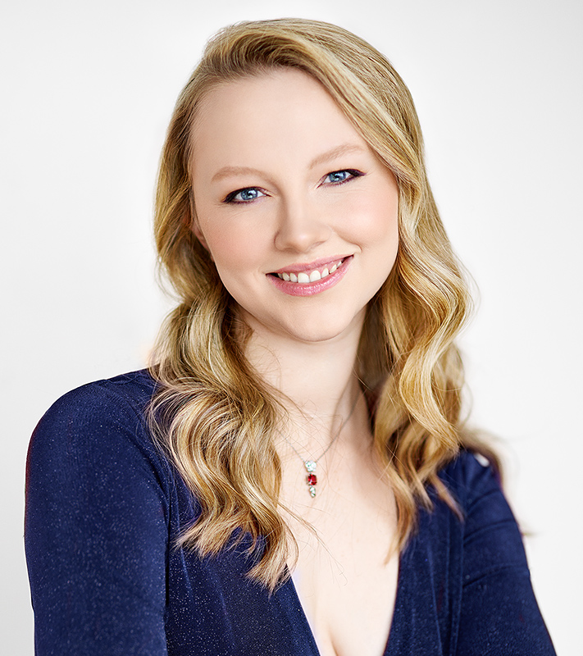

Short Bio (~75 Words)

Coloratura soprano Magdalena How is currently pursuing her Doctor of Musical Arts degree in Opera Performance at the University of British Columbia, under the tutelage of Nancy Hermiston. With a passion for telling stories through song, Magdalena savours every chance to sing onstage, from musical theatre to choral music to opera. Her recent roles include Susanna (Mozart's *Le nozze di Figaro*), Olympia (Offenbach's *Les Contes d'Hoffmann*), and Queen of the Night (Mozart's *Die Zauberflöte*) with UBC Opera.

Medium Bio (~150 Words)

Coloratura soprano Magdalena How is very pleased to be working towards her Doctor of Musical Arts degree in Opera Performance at the University of British Columbia under the tutelage of Nancy Hermiston. Magdalena has loved music all her life. She performed in musicals recreationally as a child before discovering opera, a discovery which prompted her to begin to train classically at the age of 16. Magdalena studied at McGill University before returning to her hometown of Vancouver to continue her education at UBC. She is grateful to have been the recipient of numerous performance and academic awards, including the University of BC Medal in Music. Her recent roles include Susanna in Mozart's *Le nozze di Figaro*(UBC Opera), Olympia (Offenbach's *Les Contes d'Hoffmann*), and Queen of the Night (Mozart's *Die Zauberflöte*) with UBC Opera, along with appearances with the Kamloops Symphony Orchestra (Fauré *Requiem*) and frequent performances around Vancouver.

Long Bio (~250 words)

Born in Victoria, coloratura soprano Magdalena How grew up in Ontario where she participated in choirs and musical theatre. When her family moved to Vancouver, Magdalena joined the Arts Umbrella Pre-Professional Musical Theatre Troupe and enjoyed touring musicals to local schools. At the age of 16, Magdalena discovered opera and began taking classical voice lessons at the VSO School of Music. Her love for opera prompted her to begin a Bachelor of Music degree in Performance Voice at McGill University, where she trained for three years. Returning to the West Coast in 2017, Magdalena has now earned her Master of Music degree in Opera Performance from the University of British Columbia and is on the way to achieving her Doctor of Musical Arts in Voice/Opera Performance. She studies with Nancy Hermiston and has been fortunate enough to perform at many of the events in which UBC Opera participates. Some of her favourite events have included a performance for His Royal Highness, the Aga Khan, touring to Germany and Czechia for concerts and opera performances, and singing the national anthem at Canadian Citizenship events. Magdalena has been honoured with several awards, including the UBC Medal of Music in 2019. Her recent roles include Susanna in Mozart's *Le nozze di Figaro,* Olympia (Offenbach's *Les Contes d'Hoffmann*), and Queen of the Night (Mozart's *Die Zauberflöte*) with UBC Opera. In addition to studying at UBC, Magdalena has worked as a choir section leader and soloist around Vancouver and the Lower Mainland, most recently appearing as the soprano soloist in the Fauré *Requiem*with the Kamloops Symphony Orchestra.

♪♫